Multimedia Project

Introduction:
I first learned about Piktochart from my classmates in EDUC 586 through Twitter and Blackboard discussions. According to Kirsch et. al., using resources such as Piktochart to create infographics lead to student and teacher discovery as well as enhanced student motivation (Kirsch et. al., 2016). As stated by Evans, Piktochart has a variety of templates that can be used in a variety of situations based on students’ needs (Evans, 2016). From all of the background information that I gathered, it seemed that using Piktochart to have my students create infographics would be very beneficial in enhancing student engagement and motivation.
Description of the Multimedia Project:
In my chemistry classes my students are currently learning about chemical reactions and more specifically the five types of chemical reactions: Composition, Decomposition, Single Replacement, Double Replacement, and Combustion. In the past students have mixed up some of these reactions on assessments so I had been looking for a new activity to do for this topic that would help to reinforce the information for my students. After a few Twitter and Blackboard discussions, I decided to look into and ultimately use the online Piktochart tool for this topic. I had each of my students choose one of the five types of chemical reactions and create an infographic for it. My students were able to use whichever Piktochart template they wanted (some students chose to start blank) and could organize their infographic in any manner that they wanted. The guidelines that I gave them were that they had to: include the name of the type of reaction, include at least two chemical reaction equations, include at least two pictures of specific chemical reactions, include a description of the type of chemical reaction, and include the practical applications of the type of chemical reaction that they chose. Using Piktochart to describe a type of chemical reaction and its applications applies to Next Generation Science Standard (NGSS) HS-PS2-6 Motion and Stability: Forces and Interactions: Communicate scientific and technical information about why the molecular-level structure is important in the functioning of designed materials. Researching the specific type of chemical reaction applies to ISTE-S 3a because students looked up information from various resources to use in their infographic. The use of Piktochart applies to ISTE-S 6b because my students took outside information and put it together in an infographic of their own creation.
Differentiation:
I think that students had a lot of choice in this activity. They were able to pick which of the five types of chemical reactions they wanted to create their infographic for. I had students make Piktochart accounts and showed them how to use Piktochart infographics, but students were welcome to use any form of technology that they liked to create their infographic. Most students used Piktochart to make their infographics, but some students used other resources and they turned out great as well. Students were also able to choose which template they wanted to use (some students stared with a blank page) and the format of their infographic. My students had one period (40 minutes) in class to work on their infographic and whatever they didn’t finish was to be done outside of class. During this 40-minute period, I provided different levels of guidance and answered student questions as needed. One thing that I realized throughout this process is that my students have pretty different comfort levels with new forms of technology. Some students were using features that I didn’t even know about while others needed a bit more help. The freedom and “work at your own pace” aspects of this assignment allowed me to spend more time working with struggling students.

Description of Lesson:
The focus of this lesson was on the five types of chemical reactions: Combination, Decomposition, Single-Replacement, Double-Replacement, and Combustion Reactions. Prior to this lesson, my students had learned how to balance chemical reactions which was necessary for them to fully understand the five types of chemical reactions. To start the lesson, I went through two pages in our unit packet that give descriptions and examples of each type of reaction. The notes were as follows:
Combination (also called synthesis, composition): two or more substances react to form a single compound.
A + B → AB
MgO(s) + H₂O (l) → Mg(OH)₂(s)
Decomposition: a single compound is broken into two or more products. Most decomposition reactions require energy in the form of heat, light or electricity.
AB → A + B
2H₂O(l) + electricity → 2H₂(g) + O2
Single-replacement (also called single displacement): atoms of one element replace atoms of another element in a compound.
Cationic: A + BC → B + AC
Cu(s) + AgNO₃(aq) → Ag(s) + CuNO₃(aq)
Anionic: A + BC → C + BA
Cl₂(g) + 2NaBr(aq) → Br₂(l) + 2NaCl(aq)
Double-replacement: these reactions involve an exchange of positive ions between two compounds.
AB + CD → AD + CB
AgNO₃(aq) + NaCl(aq) → AgCl(aq) + NaNO₃(aq)
Combustion: when an element or compound reacts with oxygen, usually producing energy in the form of heat or light. If combustion is complete, the products will be CO₂ and H₂O.
Fuel + O₂(g) → CO₂(g) + H₂O(l)
CH₃OH(l) + O₂(g) → CO₂(g) + 2H₂O(l)
Before we went over the types of reactions, I encouraged students to think about which type of reaction they would like to further research and make an infographic for as we went through the notes. After going through the types of reaction notes I had my students make Piktochart accounts on their devices (the day before the lesson I told students to bring in a device). Then, I had them select infographic and choose the template that they wanted. I also, showed them some basic features of Piktochart such as how to insert pictures and download and print the infographic when they were finished with it. I gave my students approximately a period (40 minutes) to work on their research and infographic. My students could organize their infographics in any way that they liked but had to include the following components: the name of the type of reaction, at least two chemical reaction equations, at least two pictures of specific chemical reactions, a description of the type of chemical reaction, and the practical applications of the type of chemical reaction that they chose. The following day, my students brought in their printed infographics and laid them out around the room. Then they walked around the room to look at each-other’s infographics and take notes on each type of chemical reaction. Afterwards, each student completed a worksheet where they looked at different reactions and labeled which type of reaction each one was. Finally, students took a quiz the following day where they had to balance and label the type of each reaction.
Assessment:
The assessment for this topic was a quiz on types of chemical reactions. For the quiz students had to balance the equations (which was learned in a previous lesson) and had to write what type of chemical reaction each equation was. The questions were as follows:
- ____Ca(s) + ____H₃PO₄(aq) → ____Ca₃(PO4)₂(s) + ____H₂(g)
Reaction type ________________________________________

- ____KBrO₃(s) → ____KBr(s) + ____O₂(g)
Reaction type________________________________________

- ____C₂H₄(s) + ____O₂(g) → ____CO₂(g) + ____H₂O(l)
Reaction type________________________________________

- ____Cr₂(SO₄)₃ + ____NaOH → ____Cr(OH)₃ + ____Na₂SO₄
Reaction type________________________________________

- ____N₂ + ____H₂ → ____NH₃
Reaction type________________________________________

In this quiz there is one type of each of the five types of chemical reactions to ensure that students know all five. This quiz asses students’ ability to balance and identify different types of chemical equations. Chemical reactions are the essence of chemistry and therefore it is extremely important that students are able to identify and understand them.
Student Artifacts:

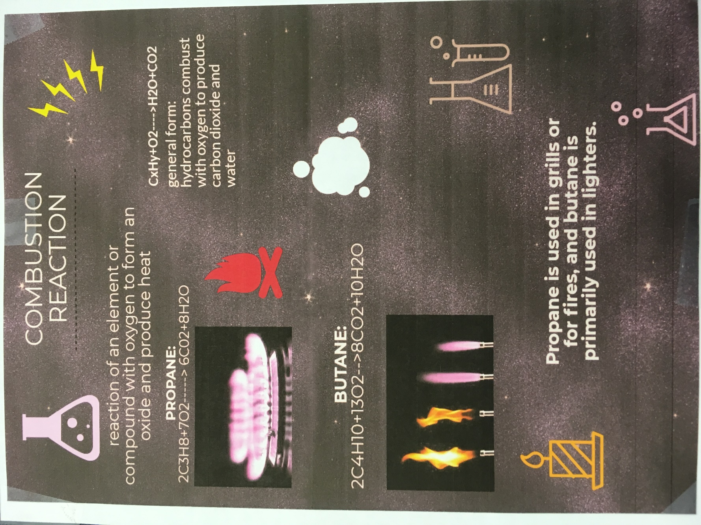

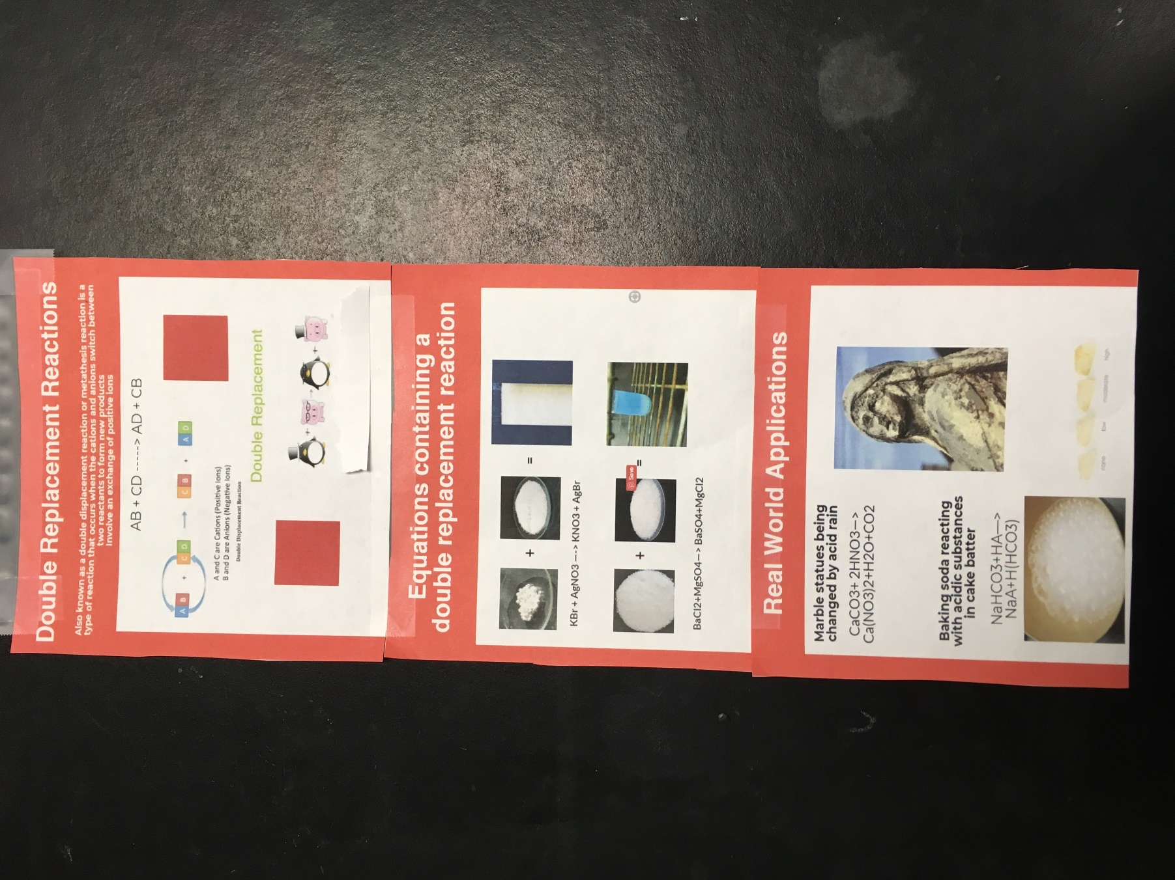

Conclusion:
I really enjoyed creating this activity for my classes. I first learned about Piktochart from my classmates in EDUC 586 and thought that it would be great to use for some of my lessons. I thought that Piktochart would be great to use for my lesson on the five types of chemical reactions because it would allow students to pick one of the five reactions to make an infographic for. I made my own Piktochart account and tested it out by making an infographic for combustion reactions and printing it out. Initially, I tired it on my iPhone which did not work as well as I thought it would, so I ended up using my laptop instead. This is why I encouraged students to bring in a laptop, if they had one, to work on their infographic with. I think that it was important that I test out the multimedia that my students would be using beforehand so that I could inform my students about how to use the multimedia and preemptively avoid as many problems as possible. This being said, some of my students still did run into a few technical difficulties with Piktochart but we were able to work through them together. Comparing last years lesson on this topic to this years, I think using Piktochart got students more excited about the topic and helped them to gain a better understanding of the types of chemical reactions. I was really impressed with my students infographics and I think that they took pride in making them.

Works Cited

Evans, R. (2016). Infographics on the Brain. Computers in Libraries, 36(6), 4-8.

Kirsch, B., Leonhirth, D., Lownes, S., Marlow, D., & Pingley, A. (2016). Improving Student
Engagement with Technology Tools. Currents in Teaching & Learning, 8(2), 50-61.

Piktochart. (2019). Piktochart. Retrieved from https://piktochart.com/

